


PJT03030.R5.SAP.FS.DPP.ENH.008.DPP De-Enrollment | 

REVIEWER(S)
Name | Title | Department | Reviewed (date/time)
Manoj Ajgaonkar | SAP Solution Architect | SAP |  | <Date / Time>
Jack Hobbick | Testing Solution Manager | Smart Energy Program |  | <Date / Time>
Santhosh Shetty | Testing Lead | HCL |  | <Date / Time>
Jessica Scott | Audit Controls, Deloitte | Deloitte |  | <Date / Time>
Clark Oeler | Audit Controls, Deloitte | Deloitte |  | <Date / Time>
Chaitanya Kodela | BTS SDM Solution Architect | BTS |  | <Date / Time>
Nancy Pierce | Business Support Consultant | Virtual Contact Center |  | <Date / Time>
Abhishek Bansal | SAP Solution Architect | SAP |  | <Date / Time>
Ramesh Swarna | HCL Technical Lead | HCL |  | <Date / Time>
Nilabja Guha | ESB Team Lead | CAP |  | <Date / Time>
John Lalicker | ESB Team | CAP |  | <Date / Time>
Alok Bedi | Grid Director | CAP |  | <Date / Time>
Brent Kassing | iFactor Lead | iFactor |  | <Date / Time>
Jason Iaccio | iFactor Team | iFactor |  | <Date / Time>
Craig Bialy | DRMS Lead | Lockheed Martin |  | <Date / Time>

APPROVER(S)
Name | Title | Department | Approval (date/time)
Clay Engel | Enrollment Vendor Program Manager | Smart Energy Program | <Date / Time>
Elody Samuelson | DPP Program Manager | Smart Energy Program | <Date / Time>
Scott Tingle | SE Project Lead | Smart Energy Program | <Date / Time>
Krishna Karunakaram | Smart Energy Project Manager | Smart Energy Program | <Date / Time>
Jeff Yankley | IT-C&APS-IT App Portfolio-Front Office | BTS | <Date / Time>
Zach Pakkala | Business Support Consultant | Customer Operations/SE CORE | <Date / Time>
Blair Estep | CE Release Manager | Smart Energy Program | <Date / Time>

CONTRIBUTORS
Name | Organization | Area of Contribution
Matt Parker | Consumers Energy | DPP Enrollment
Abhishek Bansal | SAP | DPP Enrollment
Sudipto Sinha | Capgemini | DPP Enrollment
Rajanidhi Rajasekeran | SAP | DPP Enrollment

VERSION HISTORY
Version | Date | Author(s) | Revision Notes
0.1 | 08/31/2015 | Rajanidhi Rajasekeran | Initial version
0.2 | 10/20/2015 | Ashish Bhargava | Final Draft

Table of Contents
REVIEWER(S) 2
APPROVER(S) 2
1 OBJECT REQUIREMENT SUMMARY 5
1.1 Object Information and Attributes 5
1.2 Requirements Summary and Business Driver 6
1.3 Assumptions 6
1.4 Current Functionality 6
1.5 Required Functionality 7
1.6 Project / Development Constraints 10
1.7 Performance Criteria 10
1.8 Other Objects Affected 10
1.9 External References 10
1.10 Definitions/Acronyms/Abbreviations 10
2 ENHANCEMENT DESIGN SPECIFICATIONS 11
2.1 Detail Requirements - Enhancement 11
2.2 Custom Class 14
2.3 Standard Rule 14
2.4 Custom Table Creation 14
2.5 Work Item Delivery Requirements 14
2.6 Triggering Events Determination 14
2.7 Escalation Requirements 14
2.8 Dependencies 14
2.9 Error Handling Method 14
2.10 Post Execution Notification Details 14
2.11 Process Log Details 15
2.12 Other 15
2.13 Unit Test Plan 15
2.14 Information Security 15
2.15 Audit 15
2.16 Questions / Issues / Risks 15

OBJECT REQUIREMENT SUMMARY

Object Information and Attributes

The following is current information about this object and document:
Object ID | CRM_ENH_DPP_008
Title | PJT03030.R5.SAP.FS.DPP.ENH.008.DPP During de-enrollment CE CSRs will be prompted
Team Which Owns the Object | SAP DPP Enrollment Team
System Version | CRM 7.0
Development Type | Enhancement
Priority | High
Estimated Complexity | High
Link to Process Flow

Requirements Summary and Business Driver
Ref. | PRICEFW ID | Enhancement Description
DPP-063 | CRM_ENH_DPP_008 | During de-enrollment CE CSRs will be prompted to remind the customer that they will receive a split bill

Alternatives to Object
None Identified.

Impact of Implementation
CSR will be able to de-enroll the customer from DPP and also remind the customer that they will receive split bill.

Impact of No Implementation
If not implemented, CE users will not be able to de-enroll the customer from DPP.

Assumptions
Consumers Energy will handle all DPP de-enrollments. De-enrollment will occur when a customer contacts Consumers Energy and confirms changes to a DPP-enrolled account that will change the Product/Rate Category.

The following departments or people can issue DPP De-enrollment are:
- CSR 2
- CSR 3
- VCC Management
- Customer Billing
- BCC
- Consumer Affairs

Current Functionality
There is no DPP functionality in the current system.

Required Functionality
Consumers Energy will perform all DPP de-enrollments using SAP to initiate the De-Enrollment.

Process Flow
This process can be initiated for the following scenarios:

- Customer Request De-Enrollment: The customer requests removal from the DPP program. The CE User will use the enrollment center to De-Enroll the customer from DPP. Contract Management Process “Product Change” should not allow the change of Product from RS_1007 and RS_1008 to default rate. When this occurs, the following error will be displayed: “Product change not allowed. Please navigate to the Enrollment Center to perform De-Enrollment.”

- Customer Move-Out: The customer moves-out of the DPP active Service delivery point, thereby de-enrolling from the DPP program. In this case an interaction record will be created and enrollment table will be updated with the de-enrollment status.

- Customer Request into another Program: Enrollment into another Customer Program that necessitates DPP de-enrollment. For all mutually exclusive programs, before the enrollment into another program is perform, CE User has to first de-enroll the customer from DPP, for which the CE user will use the enrollment center to do the de-enrollment.

- DPP Program Management removes Customer: DPP Program Manager may decide to de-enroll a customer from the DPP program for various reasons including; Poor Communicator, where exception management processes determines that a location is non-communicable, and hence an indirect de-enrollment from the DPP program may be required.

- Electric Smart Meter Opt Out: When a Customer elects to Opt Out for their electric meter. Prior to being able to perform the electric meter Opt Out, the user must first de-enroll the customer from DPP to allow the contract to be eligible for Opt Out.

Upon successful de-enrollment in SAP, the DPP de-enrollment request (customer data and de-enrollment data) will be sent to DRMS. This data extract will be executed in a daily batch, and no real-time communication is expected out of SAP (Covered in Functional Specification PJT03030.R5.SAP.FS.DPP.INT.DPP.005.Enrollment and De-enrollment confirmation to DRMS.v1.0). Additionally, any necessary changes to TMD due to rate change will be applied.

The following functionality will need to be delivered.
- SAP will send a de-enrollment request to iFactor upon de-enrollment confirmation.

Customer Requested De-enrollment : This is handled using Enrollment Center where the CE User should click on the de-enroll button next to the DPP enrolled program, a popup will be shown to confirm de-enrollment. On confirming de-enrollment will be performed.

Please note – Below screen images are only MOCK Ups. These images are to give a conceptual understanding only. The look and functionality may be altered slightly to comply with technical designs. Please refer to Enrollment Center functional spec for details.

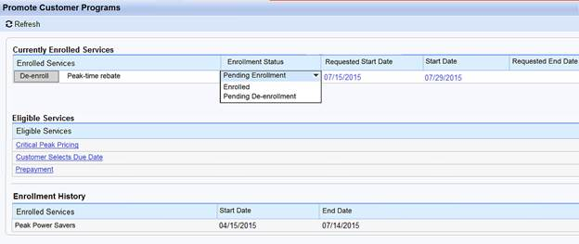

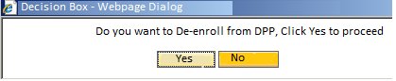

Customer Move-out : When Customer Moves out, DPP should be de-enrolled. Product need not be changed but the enrollment status has to be updated in the enrollment table
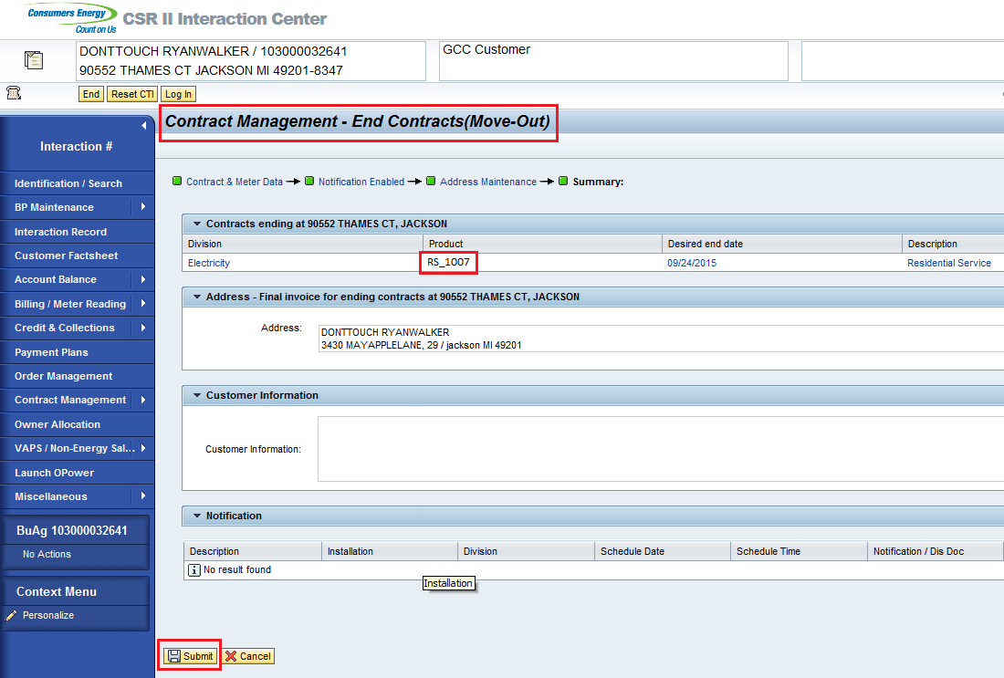

Electric Smart Meter Opt Out : In order for the electric contract to be eligible for Opting Out for their smart meter, DPP must be de-enrolled first by the user. Once de-enrollment occurs and Product is changed to a non DPP Product (ex. RS_1000), the Opt Out can occur for the electric meter.
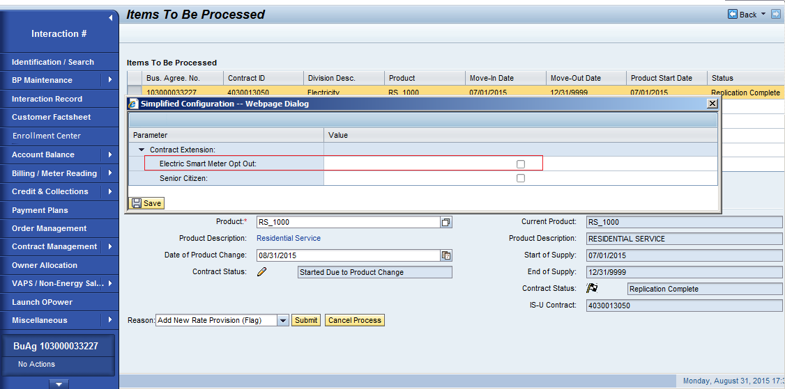

Project / Development Constraints
None Identified.

Performance Criteria
None Identified.

Other Objects Affected
None Identified.

External References
None Identified.

Definitions/Acronyms/Abbreviations

ENROLLMENT VENDOR | Device Installation Vendor
SAP | Systems, Applications & Products in Data Processing
DPP | Dynamic Peak Pricing
CRM | Customer Relationship Management SAP system
CE | Consumers Energy
CSR | Customer Service Representative
IC | Interaction Centre

ENHANCEMENT DESIGN SPECIFICATIONS

Detail Requirements - Enhancement
Customers who are enrolled in DPP can only be de-enrolled by CE. When a customer contacts Consumers Energy and confirms changes to a DPP-enrolled account that will change the Product/Rate Category, an update from CE will be sent to EV upon de-enrollment.
De-enrollment from DPP can happen in the following ways,
- Customer Move-out
- Customer Requested SE Opt-out
- Customer Requested DPP De-enrollment
- Enrollment to other rate

Customer Move-out
- CSR Clicks on the contract management--> End contract in the work center
- CSR Enters all the required details and moves to the summary
- Component and View for the move-out summary page is IUICCON/ProcessSaveButtonBar, the changes has to be done on the submit button
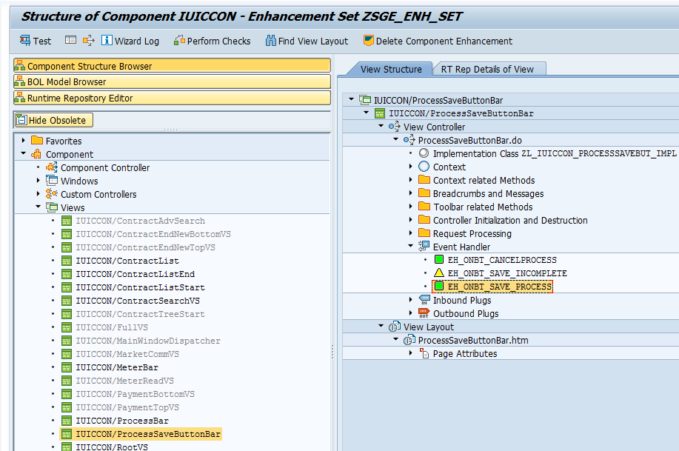

- Class/ Method which is called on clicking on the submit button is ZL_IUICCON_PROCESSSAVEBUT_IMPL/EH_ONBT_SAVE_PROCESS, Changes has to be done in this method

- In this method, there is a Custom controller reference(LR_CUCO which is referring ZL_IUICCON_CUCOCON_IMPL ), this object has an attribute GV_PROCESS_NAME which has the process performed ( i.e. New contract or change contract or End Contract )
- Check whether the process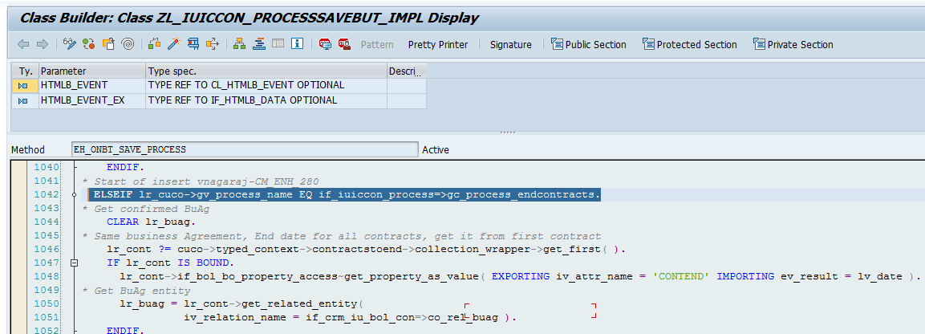
is performed is a move-out process (lr_cuco->gv_process_name EQ if_iuiccon_process=>gc_process_endcontracts).
- Check if the product is either CPR or PTR, if yes then update the Enrollment table with status "De-enrolled" with the de-enrolled date
- Also create an interaction record using Class\Method - zcl_ir_utility=>z_ir_bp_update with category "De-enrollment Completed", interaction record creation is covered in Functional Specification PJT03030.R5.SAP.FS.DPP.Customer.Enrollment.Interaction.Records.CRM.ENH.DPP.002

Enrollment to other Customer Program : Enrollment into another Customer Program that necessitates DPP de-enrollment. For all mutually exclusive programs, before the enrollment into another program is perform, CE User has to first de-enroll the customer from DPP, for which the CE user will use the enrollment center to do the de-enrollment, on de-enrollment the enrollment table will be updated with the de-enrollment status and the product change to default product will be performed. Then enrolling into other rate will follow plan rules.

SE Opt-out
- CSR Clicks on the contract management--> Change contract in the work center and selects "Product change in same document"
- CSR Changes the product to non DPP product
- CSR initiates the electric meter Opt Out in same product change view
- CSR clicks Submit button to finish the process, the changes for de-enrollment has to be done in this submit button click.
- Component and View for the Opt out screen is IUPRMAIN/ProcessExecVS, the changes has to be done on the submit button
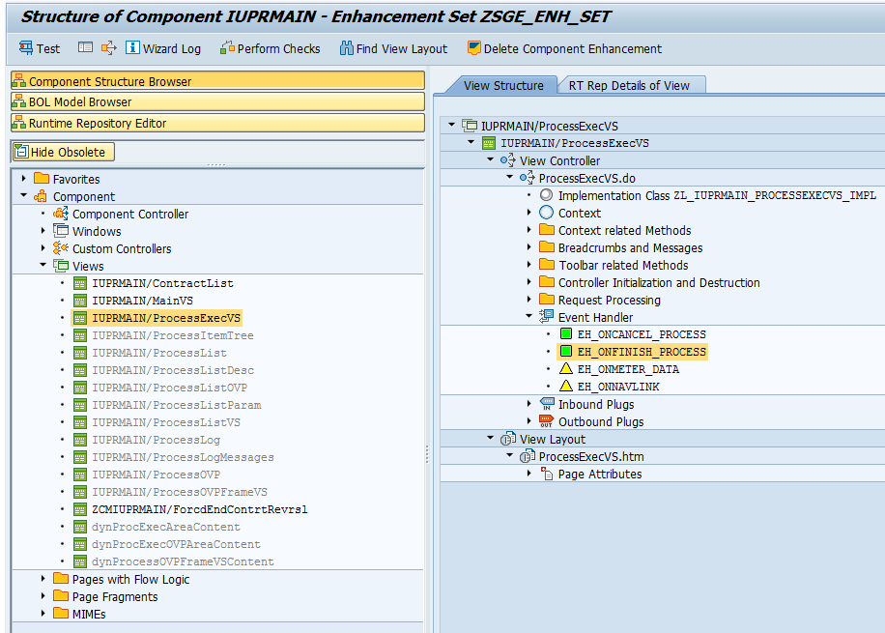
- Class/ Method which is called on clicking on the submit button is ZL_IUPRMAIN_PROCESSEXECVS_IMPL/ EH_ONFINISH_PROCESS, Changes has to be done in this method
- In this method, Check whether the selected link is product change by checking ZTYPED_CONTEXT->PROCESS->SELECTEDLINKID EQ LC_PROD_CHANGE.
- From the Item entity, get the previous entity by using the relationship "IsuOrderItemPreviousTimeSlice".
- If the previous product is a DPP product and the current product is a non DPP product then proceed with the de-enrollment process.
- Update the Enrollment table with status "De-enrolled" with the de-enrolled date
- Also create an interaction record using Class\Method - zcl_ir_utility=>z_ir_bp_update with category "De-enrollment Completed", interaction record creation is covered in Functional Specification PJT03030.R5.SAP.FS.DPP.Customer.Enrollment.Interaction.Records.CRM.ENH.DPP.002
- In case the de-enrollment is performed in the middle of billing cycle, Show a Popup with message "Mid cycle de-enrollment may result into a pro-rated bill".

Customer Requested DPP De-enrollment
- CSR Clicks on the Enrollment Center in the work center
- New Component is created for enrollment center which is covered in spec(PJT03030.R5.SAP.FS.DPP.Customer.Enrollment.CRM_ENH_DPP_004)
- CSR Clicks on the De-enroll button next to enrolled DPP program( CPR or DPP).
- De-enrollment process will happen in the on the click of the de-enroll button
- Use the existing FM Z_DLA_RATE_CHANGE to change the product category to a non-DPP product ( This FM will also create an interaction record but small changes has to be done in this FM ).
- Update the Enrollment table with status "De-enrolled" with the de-enrolled date
- Also create an interaction record using Class\Method - zcl_ir_utility=>z_ir_bp_update with category "De-enrollment Completed", interaction record creation is covered in Functional Specification PJT03030.R5.SAP.FS.DPP.Customer.Enrollment.Interaction.Records.CRM.ENH.DPP.002.
- In case the de-enrollment is performed in the middle of billing cycle, Show a Popup with message "Mid cycle de-enrollment may result into a pro-rated bill".

Custom Class
Custom Component will be created for enrollment center (covered in Functional Specification PJT03030.R5.SAP.FS.DPP.Customer.Enrollment.CRM_ENH_DPP_004).
Changes will be done in class ZL_IUPRMAIN_PROCESSEXECVS_IMPL, ZL_IUICCON_PROCESSSAVEBUT_IMPL.

Standard Rule
None Identified.

Custom Table Creation
None Identified.

Work Item Delivery Requirements
None Identified.

Triggering Events Determination
Customer Move-out
Customer Requested SE Opt-out
Customer Requested DPP De-enrollment
Enrollment to other rate

Escalation Requirements
None Identified.

Dependencies
PJT03030.R5.SAP.FS.DPP.Customer.Enrollment.Interaction.Records.CRM.ENH.DPP.002.

Error Handling Method
CRM Error message will be shown in the message area.

Post Execution Notification Details
- PJT03030.R5.SAP.FS.DPP.BusinessMasterDataInterface.CS.INT.DPP.001 --> BMD Delta will be sent to EV informing about the de-enrollment
- PJT03030.R5.SAP.FS.DPP.Customer.Enrollment.Interaction.Records.CRM.ENH.DPP.002 --> Interaction record will be created after de-enrollment
- PJT03030.R5.SAP.FS.DPP.Enrollment and De-enrollment confirmation to DRMS.CS.INT.DPP.005 --> De-enrollment confirmation will be sent to DRMS

Process Log Details
None Identified.

Other
None Identified.

Unit Test Plan

Information Security
None Identified.

Information Classification
None Identified.

Security Roles (Profiles and Authorizations)
None Identified.

Table Security (if applicable)
None Identified.

ABAP Program Security (if applicable)
None Identified.

Audit
None Identified.

Questions / Issues / Risks
None Identified.

